# SPRINT ONE - Creating the HTML Form

Two things to always remember: Save Often, Compile Often – this will save you a lot of heartache

*Note: Type in all the code when you are instructed to. You will learn much more by typing it in yourself! Also type it in EXACTLY as you see it, capitalization included. Code is case sensitive so every space and lower case/upper case letter matter. If you get stuck and are having errors please copy and paste the code directly. Also there are a few spots where I recommend copy and pasting instead of typing so look for those!*

1. Open the MadSkills-BlankStart Project:
   1. Open the NetBeans Application you installed
   2. Click “Open Project”
   3. Browse to the MadSkills-Blank Start and open
2. After the project is fully loaded click the green arrow to “run” the project.
   1. This means that the code will compile and make sure we don’t have any errors in it. You should get a blank browser window that opens up.
3. Close the browser window and click on the arrow next to “Web Pages” on the left
4. Double click the “index.html” file.
   1. We will now begin building the form.

|  |  |
| --- | --- |
| STEP ONE – TYPE IN CODE | STEP TWO – YOUR SCREEN SHOULD NOW LOOK LIKE THIS |
| <title>TYPE YOUR FUN NAME</title> |  |

1. The first item we will add is the page title. This is the text you see displayed at the very top of your browser window when you open a website. Let’s name it something fun. You’ll type it here:
2. The next step is to create our form. A form is simply a container that we put information in that we want to send somewhere else and do something with. A form starts with an HTML form tag “<form>” and ends with a closing tag </form>

Type in the following HTML code after the <body> tag.

|  |  |
| --- | --- |
| STEP ONE – TYPE IN CODE | STEP TWO – YOUR SCREEN SHOULD NOW LOOK LIKE THIS |
| <form action="MyServlet" method="get"></form> |  |

*Now click the green arrow and make sure you are able to compile and see the blank browser window again.*

1. Now we will add the input elements to our form. The first thing to add is a text label for the top of our form. We will do this by creating an <h1> tag. This stands for header and 1 is the highest level, meaning it should be the largest header in your website.

Put your cursor before the closing form tag </form> and hit enter a few times to create some spaces.

Type in the following code in between the closing form tag:

|  |  |
| --- | --- |
| STEP ONE – TYPE IN CODE | STEP TWO – YOUR SCREEN SHOULD NOW LOOK LIKE THIS |
| <h1>Enter Your New Facebook Status:</h1> |  |

*Now save and click the green arrow and make sure you are able to compile and this time you should see the “Enter Your New Facebook Status:” text. (You may have to refresh your browser to clear your cache.)*

1. Next we will create our input box.

Type the following code directly underneath the <h1> header and before the </form> tag:

|  |  |
| --- | --- |
| STEP ONE – TYPE IN CODE | STEP TWO – YOUR SCREEN SHOULD NOW LOOK LIKE THIS |
| <input type="text" name="FBStatus" value="Hello World"><br> |  |

1. Next we will create the button. The button will cause the form to create an action and do something.

Type the following code directly underneath your <input> line:

|  |  |
| --- | --- |
| STEP ONE – TYPE IN CODE | STEP TWO – YOUR SCREEN SHOULD NOW LOOK LIKE THIS |
| <button type="submit">Send Status Update</button> |  |

*Now save and click the green arrow and make sure you are able to compile and this time you should see the input box and a button on your page. Your browser window should now look like this:*

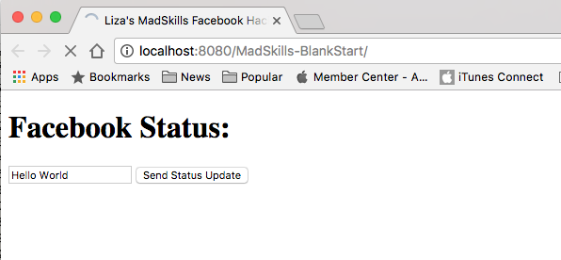

1. Now we will add a container to hold all of our elements so we can apply some visual styles to it.

Above the <form> tag, type the following two lines: (This will start the containers)

|  |  |
| --- | --- |
| STEP ONE – TYPE IN CODE | STEP TWO – YOUR SCREEN SHOULD NOW LOOK LIKE THIS |
| *<div class="pageContaniner">*  *<div class="formContainer">*  After the </form> tag, type these two lines: (This will close the containers)  *</div>*  *</div>* |  |

1. Now it’s time to make this form look pretty. We are going to link an existing style sheet to our page and see the difference. Go back up to the top and find the <head> tag. Put your cursor at the end of that tag and hit enter to go to the next line.

|  |  |
| --- | --- |
| STEP ONE – TYPE IN CODE | STEP TWO – YOUR SCREEN SHOULD NOW LOOK LIKE THIS |
| <link rel="stylesheet" href="newcss.css" type="text/css"> |  |

*Now save and click the green arrow and make sure you are able to compile and this time you should see the form on your page looking much better, See the difference?*

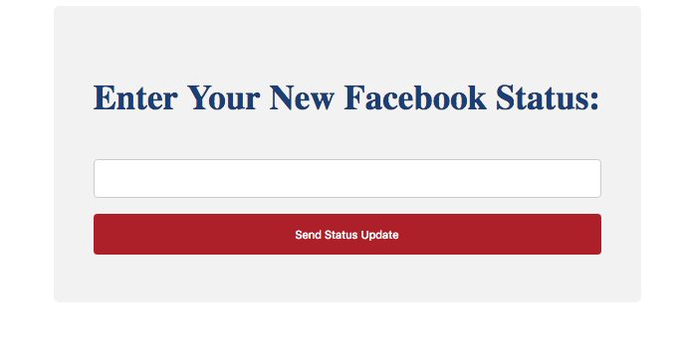

1. Let’s spend some time exploring the styles we just added to the form. Double click on the “newcss.css” file on the left hand navigation menu. That is the css (Cascading Style Sheet) file that tells the web page how to display all the elements in the page.

|  |  |
| --- | --- |
|  |  |

*Now save and click the green arrow and make sure you are able to compile and this time you should see text and button on your page change color, See the difference?*

If you have time play around with more colors and variations on your stylesheet. Meet us back in the group for the next LIVE session!